SIMATS ENGINEERING
Department of Information Technology
DSA01 – Object-Oriented Programming with C++

ASSIGNMENT 1 – CO1
Design, Implement and Validate the Fare Logic of a City Metro Smart-Card System
CO1: Apply object-oriented programming principles and C++ constructs such as data types, operators and control structures to design and write structured OOP-based programs.
Student Name | A K Selva Prabhu | Register Number | 192421224
Department Section | IT | Academic Year / Semester | Oct-dec 2026
Faculty Name | Amirtha S | Nature of Assignment | Individual
Duration | 1 Week | Total Marks | 50
Date of Submission | 10.11.2026 | Date of Evaluation
GitHub Repository | https://github.com/akselvaprabhu/C-plus-plus_192421224/tree/main/Assignments | Compiler

MARK SHEET (Rubric-based Evaluation)
Task | Task Title | Max | Marks Awarded | Remarks
1 | Object-Oriented Analysis | 4
2 | Tokens, Keywords, Identifiers and Constants | 3
3 | Data Types and Compatibility | 4
4 | Implicit Conversions | 4
5 | Operators and Precedence | 4
6 | Control Structures | 4
7 | Procedural vs Object-Oriented | 4
8 | Input and Output | 4
9 | Implementation and Testing | 4
10 | Expectation vs Execution | 4
11 | Final Recommendation | 4
12A | Re-evaluate: Impact Analysis | 2
12B | Re-evaluate: Evaluation of Original Design | 2
12C | Re-evaluate: Adaptation or Redesign | 2
12D | Re-evaluate: Evidence-Based Defence | 2
 | TOTAL | 50 |  | Percentage:
OVERALL REMARKS

Student Signature | Faculty Signature | Program Director

TASK 1 – UNDERSTAND THE PROBLEM AND IDENTIFY THE OBJECTS
The metro system is modelled as cooperating objects. Each object owns the information and operations that naturally belong to it. This reduces duplicated fare logic and makes the rules easier to validate.
Object | Important data | Behaviour / justification
Passenger | ID, passenger category (regular/student/senior) | Identifies the traveller and determines an eligible concession. Keeping category with the passenger avoids repeating category checks at every gate.
SmartCard | Card ID, balance in paise | canTravel(), deduct(), recharge(). It protects the balance and ensures a journey cannot leave less than Rs.50.
Journey | Entry zone, exit/farthest zone, hour, date | isPeak(), validate(), calculateFare(). It represents one trip and supplies the facts needed to price it.
Zone | Inner, Middle, Outer (later Airport) | A strongly typed enum identifies the destination/farthest zone without ambiguous numeric values.
FareTable | Base fare per zone, surcharge and discount rates | Returns the configured fare. One central table makes fare revision safer than changing literals in many functions.
Procedural style: separate variables such as balance, zone and hour are passed to free functions such as calculateFare() and canTravel(). All functions must agree on the same rules. In OOP, SmartCard, Journey and FareTable group state with the operations that use it.
OOP principles in this system
Encapsulation: SmartCard keeps balance private; only validated methods can change it.
Abstraction: the gate calls calculateFare() and deduct() without needing to know every internal arithmetic step.
Inheritance: StudentPassenger and SeniorPassenger may derive from Passenger when their concession rules or additional data differ.
Polymorphism: a virtual concessionRate() function can return different rates for regular, student and senior passenger types.
Mandatory journey invariants
Balance after deduction must be at least 5,000 paise (Rs.50).
Fare and balance are never negative; invalid zones and invalid hours are rejected.
Peak intervals are [08:00,10:00) and [17:00,20:00): 8 AM and 5 PM are peak; 10 AM and 8 PM are not.
A rejected journey must not change the card balance.
Assumption: the assignment does not state the student/senior concession percentages. The first implementation therefore keeps concession policy configurable and does not invent a percentage.
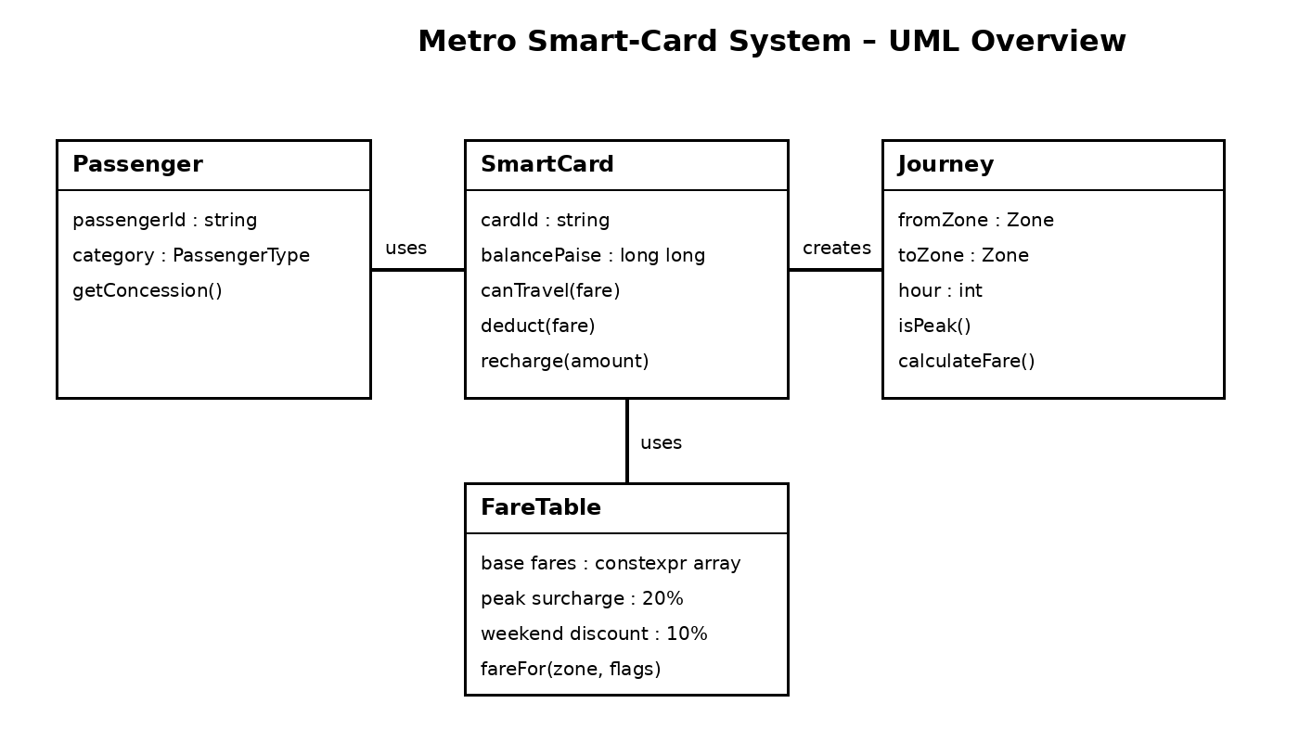
Complexity comparison: both procedural and OOP designs calculate one fare in O(1) time and store one card balance in O(1) space. The performance is effectively unchanged. When a rule changes, procedural code may require edits in multiple functions; encapsulated OOP code centralises the change in FareTable or SmartCard.

TASK 2 – TOKENS, KEYWORDS, IDENTIFIERS AND CONSTANTS
A C++ program is made from tokens. Correct naming and centralised constants reduce accidental inconsistency.
Token kind | Examples from this program | Purpose
Keywords | class, enum, constexpr, if, return, public, private | Reserved language words that define program structure.
Identifiers | SmartCard, balancePaise, calculateFare | Programmer-defined names for classes, variables and functions.
Constants | 5000, 20, Zone::Outer | Fixed values that should not change during execution.
Operators | + , -, %, >=, &&, +=, ?: | Perform arithmetic, comparison and logical operations.
Punctuators | { } ( ) ; , :: | Separate statements, blocks, arguments and scopes.
Choosing a constant mechanism
#define PEAK_RATE 20 is a preprocessor text substitution. It has no type or normal C++ scope and can cause surprising substitutions.
const int rate = 20 creates a typed read-only object; its value is not necessarily usable in every compile-time context.
constexpr int PEAK_RATE = 20 guarantees a compile-time constant when its initializer is constant. It is suitable for array sizes and compile-time fare configuration.
enum class Zone { Inner, Middle, Outer };
constexpr long long BASE_PAISE[] = {1000, 2000, 3000};
constexpr int PEAK_SURCHARGE_PERCENT = 20;
constexpr long long MIN_BALANCE_PAISE = 5000;
enum class is preferred to an unscoped enum because its values are scoped (Zone::Inner) and do not implicitly convert to int. This prevents accidental comparison with unrelated integers.
Identifier conventions
Use descriptive camelCase for variables/functions (balancePaise, calculateFare).
Use PascalCase for class names (SmartCard, FareTable) and UPPER_SNAKE_CASE for constants.
Identifiers cannot begin with a digit, cannot contain spaces, and cannot be C++ keywords. Names should communicate units, e.g. farePaise rather than fare.
Alternative using macros: macros have no type checking and no C++ namespace scope. constexpr and enum class provide compile-time checking and safer scope. A macro normally occupies no storage; a constexpr value also normally requires no run-time storage when used as a constant expression. Neither choice materially changes the O(1) fare calculation time. constexpr is therefore the safer design.

TASK 3 – CHOOSE DATA TYPES AND CHECK TYPE COMPATIBILITY
Value | Recommended type | Reason / expected size on common 64-bit g++
Fare / balance | long long (paise) | Exact integer arithmetic; commonly 8 bytes.
Peak flag | bool | Two logical states; commonly 1 byte.
Zone | enum class Zone | Named, type-safe finite set; underlying int commonly 4 bytes.
Hour / minute | int | Small signed whole numbers; commonly 4 bytes.
Journey count | long long | Safely holds millions and larger totals; commonly 8 bytes.
Passenger initial | char | Single character; commonly 1 byte.
Display-only ratio | double | Approximate floating-point value; commonly 8 bytes.
Temporary inferred value | auto | Lets compiler infer a type from a clear initializer.
The exact sizeof values depend on the compiler and platform. Confirm locally using sizeof(bool), sizeof(int), sizeof(long long), sizeof(double), sizeof(char) and sizeof(Zone). Typical g++ values are shown above, not guaranteed by the C++ standard.
Why integer paise?
Rs.10.20 is represented as 1,020 paise. Integer addition and subtraction remain exact. Binary floating-point cannot represent many decimal fractions exactly, so repeated double additions can produce tiny errors. Fare decisions and minimum-balance checks must not depend on approximate decimal values.
Type compatibility
In 7 / 2, both operands are int, so integer division produces 3. Assigning that result to double gives 3.0, not 3.5.
In 7.0 / 2, the int is converted to double and the result is 3.5.
An int used as a condition converts to bool: zero is false and non-zero is true.
Mixing signed and unsigned values can convert a negative signed value to a large unsigned value, changing comparisons.
Range and network collection
Use <climits> values such as INT_MAX and LLONG_MAX to inspect limits. If the maximum fare is Rs.36, then 3,000,000 journeys collect Rs.108,000,000 (Rs.10.8 crore) before considering concessions. This is below the usual 32-bit INT_MAX in paise only if expressed as 10,800,000,000 paise? It is 10,800,000,000 paise, which exceeds 2,147,483,647; therefore int is not sufficient for the total in paise. long long is appropriate.
Alternative: double rupees
Both long long and double are commonly 8 bytes, and each addition is O(1). However, double stores approximate binary values. With n additions, small representation errors can accumulate; integer paise has zero rounding error for whole-paise fares. Use long long for accounting and convert to double only for non-critical display or analytics.
#include <iostream>
#include <climits>
int main() {
std::cout << sizeof(int) << ' ' << sizeof(long long) << ' '
<< sizeof(double) << '\\n';
std::cout << INT_MAX << ' ' << LLONG_MAX << '\\n';
}

TASK 4 – CONTROL IMPLICIT CONVERSIONS
Implicit conversions happen when C++ changes a value's type without an explicit cast. These should be understood and controlled at fare boundaries.
Integer division: int a=7, b=2; double c=a/b; produces 3.0 because division happens before assignment.
Explicit conversion: double d=static_cast<double>(a)/b; produces 3.5.
char promotion: when ch is used in ch+1, char is promoted to int; 'C'+1 is printed as the integer code 68 on ASCII-compatible systems.
int-to-bool: bool flag=5; stores true. Default stream output is 1; std::boolalpha prints true.
Signed/unsigned comparison: comparing -1 with unsigned 1 converts -1 to a large unsigned value, so the comparison s<u is false on the usual 32-bit unsigned int implementation.
Exact predicted output for the supplied program
3 3.5
C 68
1 true
s >= u
Explanation: a/b is integer division; static_cast<double>(a) forces floating-point division. 'A'+2 gives the character C. ch+1 promotes C to its integer code and adds one. bool is printed first numerically and then as a word after boolalpha. The signed value -1 is converted to unsigned for the final comparison.
Safer code patterns
int hour{8}; // no narrowing
double ratio = static_cast<double>(7) / 2;
long long farePaise{3000};
bool peak = (hour >= 8 && hour < 10) ||
(hour >= 17 && hour < 20);
The declaration int x{3.7}; is ill-formed because list initialisation rejects narrowing. Use a deliberate conversion only when it is valid. If every conversion were explicit, the program would be clearer and some mistakes would be caught at compile time. Runtime and memory complexity remain O(1); casts generally do not add meaningful storage or processing cost.

TASK 5 – WRITE CORRECT EXPRESSIONS WITH THE RIGHT PRECEDENCE
bool peak = (hour >= 8 && hour < 10) ||
(hour >= 17 && hour < 20);
long long fare = baseFare;
if (peak) fare += baseFare * 20 / 100;
if (eligible) fare -= fare * concessionPercent / 100;
Parentheses make the intended intervals explicit. Relational operators (>=, <) are evaluated before logical AND (&&), and && before logical OR (||). The conditional operator ?: has lower precedence than most arithmetic and comparison operators, so parentheses improve readability. Compound assignment fare += amount means fare = fare + amount.
x++ returns the old value and then increments x; ++x increments first and returns the new value.
i = i++ should be avoided: it is confusing and historically has had undefined/unspecified behaviour concerns depending on language version and expression context. Write i++; as a separate statement.
Integer division truncates toward zero: 10/3 is 3 and -10/3 is -3. The remainder has the sign of the dividend: -10%3 is -1.
Exact predicted output for the supplied program
11 16
9 6 4
6 4
3 1 -3 -1
18
Line 1: multiplication is evaluated before addition; parentheses force (x+y) first. Line 2: x++ contributes 5 then x becomes 6; ++y makes y=4 and contributes 4, so z=9. Line 3: max(6,4)=6; % and * have equal precedence and associate left-to-right, so 6%4*2=4. Line 4: integer division and remainder follow truncation toward zero. Line 5: i takes 0,3,6,9 and k becomes 18.
Alternative lookup-table peak test
constexpr bool PEAK[24] = {
false,false,false,false,false,false,false,false,
true,true,false,false,false,false,false,false,
false,true,true,true,false,false,false,false
};
// peak = PEAK[hour]; after validating 0 <= hour && hour < 24
Both the Boolean expression and table lookup are O(1). The table uses 24 bool elements (typically about 24 bytes), and can make repeated checks simpler. The expression uses no table storage and communicates the two time ranges directly. The chosen expression is preferable for this small rule; a table becomes attractive when schedules are more complex.

TASK 6 – DESIGN THE CONTROL STRUCTURES
Algorithmic pseudocode
ALGORITHM CalculateMetroFare
INPUT zone, hour, balancePaise
IF zone is not Inner, Middle or Outer THEN
OUTPUT "Invalid zone"; STOP
END IF
IF hour < 0 OR hour > 23 THEN
OUTPUT "Invalid hour"; STOP
END IF
SELECT zone
CASE Inner: baseFare <- 1000
CASE Middle: baseFare <- 2000
CASE Outer: baseFare <- 3000
END SELECT
peak <- (8 <= hour < 10) OR (17 <= hour < 20)
farePaise <- baseFare
IF peak THEN farePaise <- baseFare + baseFare*20/100
IF balancePaise - farePaise >= 5000 THEN
balancePaise <- balancePaise - farePaise
OUTPUT farePaise, balancePaise
ELSE
OUTPUT "Denied (low balance)"
END IF
END ALGORITHM
Control-structure choices
if–else is best for range checks, invalid input, peak status and balance decisions.
switch is readable for a finite set of zone values; include a default branch to reject invalid values.
The conditional operator is suitable for a short value selection, not for a multi-step fare workflow.
A counted for loop is appropriate when the number of journeys is known. A range-based for loop is clearest when iterating over a collection of Trip objects. A while loop is useful when input continues until an end marker.
continue skips an invalid journey and moves to the next; break exits when processing must stop, such as a fatal input error.
Completed code for TODO 1 and TODO 2
long long fare(Zone z, bool peak) {
long long base = 0;
switch (z) {
case Zone::Inner: base = BASE_PAISE[0]; break;
case Zone::Middle: base = BASE_PAISE[1]; break;
case Zone::Outer: base = BASE_PAISE[2]; break;
default: return -1; // invalid zone sentinel
}
if (peak) base += base * PEAK_SURCHARGE_PERCENT / 100;
return base;
}
bool canTravel(long long balance, long long f) {
return f >= 0 && balance >= f &&
balance - f >= MIN_BALANCE_PAISE;
}
For the given starting balance Rs.100: Inner off-peak costs Rs.10, leaving Rs.90. Outer peak costs Rs.36, leaving Rs.54. Middle off-peak would leave Rs.34, below the Rs.50 minimum, so it is denied and the balance remains Rs.54.

Alternative array lookup: a constexpr fare array provides O(1) indexing and is easy to extend by adding Airport. A switch is also O(1) for a small fixed set and can compile to a jump table. The array uses one entry per zone; both approaches require explicit validation of the enum/index.

TASK 7 – FROM PROCEDURAL TO OBJECT-ORIENTED
Procedural version
long long balancePaise = 10000;
bool canTravel(long long balance, long long fare) {
return fare >= 0 && balance - fare >= 5000;
}
bool deduct(long long& balance, long long fare) {
if (!canTravel(balance, fare)) return false;
balance -= fare;
return true;
}
Object-oriented version
class SmartCard {
private:
long long balancePaise;
static constexpr long long MIN_BALANCE = 5000;
public:
explicit SmartCard(long long initial) : balancePaise(initial) {}
long long balance() const { return balancePaise; }
bool canTravel(long long fare) const {
return fare >= 0 && balancePaise >= fare &&
balancePaise - fare >= MIN_BALANCE;
}
bool deduct(long long fare) {
if (!canTravel(fare)) return false;
balancePaise -= fare;
return true;
}
bool recharge(long long amount) {
if (amount <= 0) return false;
balancePaise += amount;
return true;
}
};
The procedural version can be correct, but every caller must pass the right balance variable and remember to call the validation function before subtraction. In the OOP version, balancePaise is private and deduct() is the only normal route to reduce it. A negative balance or a balance below the minimum cannot be created through the public interface.
Comparison | Procedural | OOP SmartCard
State | Separate variables | Private member data
Validation | Caller must follow convention | Enforced inside methods
Rule change | May affect multiple functions/call sites | Change one class constant/method
Time / space | O(1) per operation; O(1) per card | Same asymptotic cost
If balance were public, any function could write card.balancePaise = -100 or subtract a fare without checking the Rs.50 rule. Time and space would remain unchanged, but encapsulation would be lost and the central invariant could be broken. Therefore private state is strongly recommended.

TASK 8 – READ AND PRINT DATA SAFELY
#include <iostream>
#include <limits>
int readHour() {
int hour;
while (true) {
std::cout << "Enter hour (0-23): ";
if (std::cin >> hour && hour >= 0 && hour <= 23) return hour;
std::cout << "Invalid input. Try again.\\n";
std::cin.clear();
std::cin.ignore(std::numeric_limits<std::streamsize>::max(), '\\n');
}
}
cin >> reads formatted values. If a user enters letters where an integer is expected, the stream enters a failure state. cin.fail() detects the error; cin.clear() resets the state; ignore() discards the remaining bad line so the next read can proceed. Without clearing, later reads fail immediately.
Money formatting
#include <iomanip>
std::cout << "Fare Rs " << farePaise / 100 << '.'
<< std::setw(2) << std::setfill('0')
<< farePaise % 100 << std::setfill(' ') << '\\n';
The above prints paise as two digits (for example Rs 10.05). fixed and setprecision(2) are useful when displaying a double, but the accounting value should remain integer paise. A report should show journey number, zone, peak/off-peak, fare, decision and remaining balance.
Trip | Zone | Time | Fare | Decision | Balance
1 | Inner | 09:00 | Rs.12.00 | Accepted | Rs.88.00
2 | Outer | 18:00 | Rs.36.00 | Accepted | Rs.52.00
3 | Middle | 12:00 | Rs.20.00 | Denied | Rs.52.00
Alternative getline() and stoi()
With getline(), the program receives a complete line, then stoi() converts it inside try/catch. Reading and parsing a line of length L takes O(L) time and O(L) buffer space. getline is convenient when inputs contain spaces and allows precise validation of the whole line; cin >> is simpler for token-based numeric input but needs stream recovery. Both are acceptable when errors are handled.

TASK 9 – IMPLEMENT AND TEST THE FARE LOGIC
The following test matrix covers each zone, peak/off-peak conditions, exact time boundaries, minimum balance, invalid data and a hand-calculated batch. Base fares are Rs.10/Rs.20/Rs.30 and peak adds 20%.
Test | Input | Expected result | Reason
T1 | Inner, 07:59 | Rs.10.00 | Before peak
T2 | Inner, 08:00 | Rs.12.00 | Peak begins
T3 | Middle, 10:00 | Rs.20.00 | Peak ends; off-peak
T4 | Outer, 17:00 | Rs.36.00 | Evening peak begins
T5 | Outer, 20:00 | Rs.30.00 | Peak ends
T6 | Balance Rs.60, Inner peak | Accepted; balance Rs.48? | Rejected: remaining must be >= Rs.50
T7 | Balance Rs.62, Inner peak | Accepted; balance Rs.50 | Exactly minimum allowed
T8 | Unknown zone | Rejected | Invalid enum/input
T9 | Recharge -100 paise | Rejected | Negative recharge invalid
T10 | Hour entered as abc | Prompt again / reject | cin failure recovery
Five-journey hand calculation
Journey | Zone / time | Fare | Running total
1 | Inner 07:30 | Rs.10 | Rs.10
2 | Middle 08:30 | Rs.24 | Rs.34
3 | Outer 12:00 | Rs.30 | Rs.64
4 | Inner 17:30 | Rs.12 | Rs.76
5 | Middle 20:00 | Rs.20 | Rs.96
The five fares total Rs.96.00 (9,600 paise). This is the sum of fares before applying a card's minimum-balance acceptance rule.
Core implementation pattern
long long baseFare(Zone z) {
switch (z) {
case Zone::Inner: return 1000;
case Zone::Middle: return 2000;
case Zone::Outer: return 3000;
}
return -1;
}
bool isPeak(int h) {
return (h >= 8 && h < 10) || (h >= 17 && h < 20);
}
long long calculateFare(Zone z, int h) {
if (h < 0 || h > 23) return -1;
long long b = baseFare(z);
if (b < 0) return -1;
return isPeak(h) ? b + b * 20 / 100 : b;
}
The test-table approach runs in O(t) for t test cases and stores O(t) test records. Adding a new boundary case means adding one row, making regression testing more repeatable than scattered manual checks.
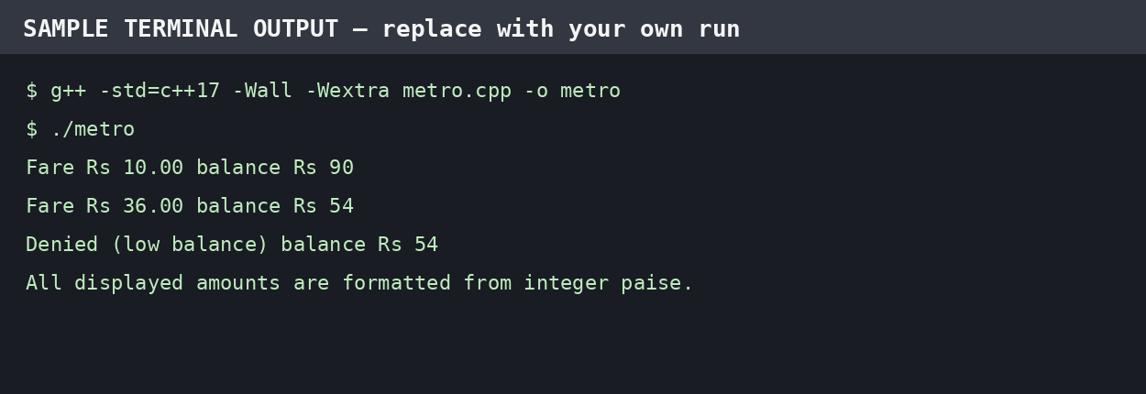

TASK 10 – COMPARE EXPECTATIONS WITH EXECUTION
For the comparison, assume the maximum fare in the original three-zone model is Rs.36 (3,600 paise), and consider a worst-case total in which every journey costs that amount.
Journeys | Total in rupees | Total in paise | Fits 32-bit signed int paise?
20,000 | Rs.720,000 | 72,000,000 | Yes
500,000 | Rs.18,000,000 | 1,800,000,000 | Yes, narrowly
3,000,000 | Rs.108,000,000 | 10,800,000,000 | No
The network total at three million journeys exceeds the usual INT_MAX (2,147,483,647) when stored in paise. A signed 32-bit int can overflow; signed overflow is undefined behaviour in C++. Use long long for cumulative paise.
Integer-paise versus double totals
Integer paise gives an exact sum for fares expressed in whole paise. Double rupees can represent the same broad magnitude, but decimal fractions such as 0.1 are not exact binary fractions. The difference depends on the exact sequence and number of additions; it should be measured by a small program rather than invented. A useful experiment is to add 0.1 to a double 1,000,000 times and compare with 100,000.00.
double total = 0.0;
for (int i = 0; i < 1000000; ++i) total += 0.1;
std::cout << std::fixed << std::setprecision(10) << total << '\\n';
Compiler warnings with -Wall -Wextra
-Wsign-compare: warns when signed and unsigned values are compared; validate and convert deliberately.
-Wconversion / -Wfloat-conversion (if enabled): may warn about potentially lossy narrowing or floating-point conversion.
-Wunused-variable / -Wunused-parameter: indicates declared values that are not used.
Exact warnings depend on the submitted source and compiler version. Compile with g++ -std=c++17 -Wall -Wextra -Wconversion -pedantic to obtain additional diagnostics and record the actual messages.
Accumulator | At 3,000,000 × 3,600 paise | Conclusion
int | 10,800,000,000 exceeds usual signed 32-bit range | Unsafe; overflow
long long | Value fits comfortably | Recommended; exact
double | Magnitude fits; decimal may be approximate | Suitable for approximate analytics, not fare accounting
Each addition is O(1). int commonly uses 4 bytes; long long and double commonly use 8 bytes. The larger accumulator costs only a few extra bytes and prevents a serious correctness failure.

TASK 11 – RECOMMEND AND DEFEND THE FINAL DESIGN
Recommended architecture
Use enum class Zone for named zones and long long paise for all stored money.
Use constexpr fare and percentage constants, grouped in FareTable.
Use SmartCard with a private balance and validated canTravel(), deduct() and recharge() methods.
Use Journey to store zone, time and date; validate inputs before fare calculation.
Use functions for peak-hour determination and formatted receipt output.
Fare revision procedure
A normal fare revision is made in one central fare table, followed by recompilation, regression tests for every zone and boundary, and deployment. No fare literal should be duplicated in the gate logic. For larger systems, a versioned configuration file may be preferable.
Limitations
The original three-zone model does not yet define concession percentages or how student/senior eligibility is verified.
A fixed 20% peak surcharge uses integer arithmetic; if fractional paise rates are introduced, rounding policy must be documented.
The simple example does not include refunds, offline synchronisation, fraud detection, concurrent card taps or transaction persistence.
A monthly pass needs validity dates, eligible zones and usage rules beyond a stored-value balance.
Whole-network suitability
The fare calculation and card check are O(1) per journey. For 3,000,000 journeys, total processing is O(n), and a stream-processing design can handle journeys one by one without storing all records. Use long long for network totals and persistent transaction logs for auditability. Capacity and concurrency still require load testing.
Configuration-file alternative
At start-up, read z fare entries from a validated configuration file. Loading costs O(z) time and O(z) storage; each fare lookup remains O(1). The benefit is changing fares without recompiling the executable. The risks are malformed or missing configuration, inconsistent versions across gates and tampering. Validate the complete file, reject invalid values and use a signed/versioned configuration. For a tiny fixed fare table, constexpr is simpler; for frequent policy changes, configuration is more maintainable.
Evidence-based defence: integer paise avoids decimal rounding, long long avoids network-total overflow, and encapsulation enforces the minimum-balance invariant. These are correctness improvements independent of network size.

TASK 12 – DAY-4 DESIGN CHALLENGE: RE-EVALUATE AND ADAPT
A. Impact analysis
New requirements: Airport zone costs Rs.60; weekend journeys receive 10% discount; weekend discount does not combine with peak surcharge; a monthly pass permits unlimited travel in two selected zones.
Zone enum and fare table gain Airport. Base fare array changes from three to four entries.
The peak expression remains unchanged, but fare selection now considers weekend status.
Journey gains a weekend/date flag. Passenger or SmartCard logic must identify a valid monthly pass.
A new Pass class stores start date, expiry date and two allowed zones.
B. Evaluate the original design
The original switch can be extended with an Airport case, but every additional zone requires editing the switch. A fare array indexed by a validated enum value is easier to extend. SmartCard remains useful for stored-value cards, but a pass is a different payment entitlement and should not be represented by a fake zero balance.
Worked examples: Airport off-peak weekday = Rs.60.00; Airport peak weekday = Rs.72.00. Airport weekend fare = Rs.54.00, even if the time is peak, because the weekend discount replaces rather than combines with the peak surcharge. A valid pass covering Inner and Middle accepts those zones without deducting stored value; Outer and Airport require another payment method.
C. Revised design – code
enum class Zone { Inner, Middle, Outer, Airport };
constexpr long long FARES[] = {1000, 2000, 3000, 6000};

long long revisedFare(Zone z, bool peak, bool weekend) {
int index = static_cast<int>(z);
if (index < 0 || index >= 4) return -1;
long long amount = FARES[index];
if (weekend) amount = amount * 90 / 100; // replaces peak surcharge
else if (peak) amount = amount * 120 / 100;
return amount;
}

class MonthlyPass {
int firstZone, secondZone;
int validFromDay, validToDay;
public:
MonthlyPass(int a, int b, int from, int to)
: firstZone(a), secondZone(b), validFromDay(from), validToDay(to) {}
bool covers(int zone, int day) const {
return day >= validFromDay && day <= validToDay &&
(zone == firstZone || zone == secondZone);
}
};
Production code should validate enum values before converting to an array index and should use a proper date type rather than integer day placeholders. A pass journey is accepted only when the pass is active and the journey zone is one of its two selected zones.
D. Evidence-based defence
Scenario | Expected fare / decision | Reason
Airport weekday off-peak | Rs.60.00 | Base fare
Airport weekday peak | Rs.72.00 | 20% surcharge
Airport weekend at peak time | Rs.54.00 | 10% weekend discount replaces peak
Monthly pass: Inner, valid date | Accepted; Rs.0 stored-value fare | Zone is covered
Monthly pass: Airport, valid date | Not covered by pass | Airport not one of selected zones
Decision: MODIFY the design rather than discard OOP. Retain SmartCard for stored value, add a FareTable array and a separate MonthlyPass class, and centralise the precedence rule between weekend and peak. This minimises changes to card balance protection while accommodating the new product. Test all zone × peak × weekend combinations and pass boundary dates before deployment.

FINAL VALIDATION, SAMPLE INPUT/OUTPUT AND SUBMISSION CHECKLIST
The following terminal-style panels are illustrative examples prepared for this report. They are not proof that the program was executed on the student's computer. Replace them with genuine screenshots from the local compiler before final submission, as the assignment requires individual execution and GitHub evidence.
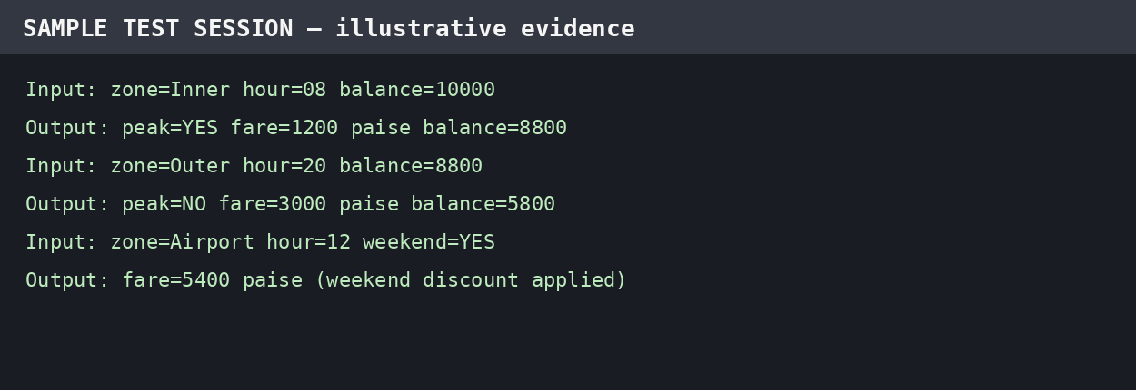
Suggested compilation and run commands
g++ -std=c++17 -Wall -Wextra -Wconversion -pedantic metro.cpp -o metro
./metro
GitHub repository structure
DSA01-<RegisterNumber>-Assignment1/
README.md
Task01/ analysis.md uml.png
Task02/ constants.cpp
Task03/ types.cpp
Task04/ conversions.cpp
Task05/ operators.cpp
Task06/ pseudocode.txt fare.cpp
Task07/ procedural.cpp smartcard.cpp
Task08/ input_output.cpp
Task09/ metro.cpp test-cases.csv screenshots/
Task10/ totals.cpp measurements.txt
Task11/ recommendation.md
Task12/ revised_fare.cpp pass_tests.txt
README.md must record
Student name and register number; repository URL; compiler name/version (e.g. g++ 13.3.0).
Exact compile command and run instructions for every task.
Short result summary, input files, actual output screenshots and progressive commits (at least one commit per task).
Commit the work progressively; do not upload everything in a single final commit.
Final conclusion
The most reliable design stores money in integer paise, uses long long for balances and totals, centralises policy in constexpr/configuration data, uses explicit conversion and validation, and protects card state through encapsulation. The revised system adds Airport, a mutually exclusive weekend discount and a separate monthly-pass entitlement. Its per-journey fare and eligibility checks remain O(1), while processing n journeys is O(n).
Before submission, compile and run every code listing, capture genuine input/output screenshots, verify all expected boundary cases, add the actual GitHub link to the cover page, and ensure the report reflects the student's own test results.

